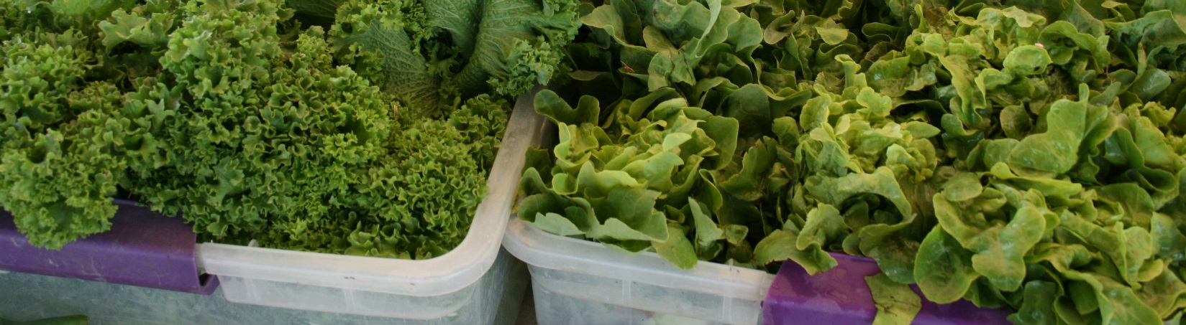

emergency Food and shelter program

EMERGENCY FOOD AND SHELTER PROGRAM
Phase 35 – Broomfield County Application Form

$3,362 has been allocated to Broomfield County for Phase 35 of the Emergency Food and Shelter Program.

Emergency Food and Shelter Program (EFSP) funds are intended to respond to changing hunger and homelessness needs in Broomfield County, not to maintain the status quo nor replace current funding. Eligible organizations may apply for funds in one or more of nine service categories:
- Served Meals: Hot or cold prepared meals, which are served or delivered to clients/customers.
- Other Food: Food vouchers for grocery orders, food boxes, or food purchased by food banks.
- Mass Shelter: Provides shelter within own facility.
- Other Shelter: Provides shelter outside of own facility (motel, SRO, another shelter, etc.).
- Supplies/Equipment: Essential supplies and equipment purchased for use in a mass feeding or sheltering facility.
- Building Code Repairs/Accessibility Improvements: Expenditures for building code repairs or accessibility improvements of a mass shelter or mass feeding facility. Maximum expenditure is $2,500. Must have a documented code violation of and National Board pre-approval to receive.
- Rent/Mortgage: Provide clients with rent/mortgage assistance.
- Utilities: Provide clients with utility assistance.

Applications are due end of business day, Friday, November 2, 2018. Please complete this form and email it as a Word or Adobe PDF document, along with your organization’s most recently completed balance sheet and statement of revenue/expenses, to Serita Randall at Serita.Randall@gmail.com by November 1. Please contact Tiernan Doyle with questions at Tiernan.Doyle@unitedwayfoothills.org.
A. Applicant Organization
please type your answers within the provided boxes; use Arial 11 point font
Agency Name:

Contact Person:

Street/Mailing Address:

City/State/Zip Code:

Phone Number:

Fax Number:

Email Address:

Website:

Federal Employer Identification Number (FEIN):

Data Universal Numbering System (DUNS) Number:

Agency Total Current Fiscal Year Budget: $

Total # Clients/Customers Served Agency-wide During Prior Program Year:

B. EFSP Funding History
enter N/A if you did not receive EFSP funding in a given phase
Phase 32 Amount Received: $

Phase 33 Amount Received: $

Phase 34 Amount Received: $

C. Eligibility Criteria
1. Nonprofit Status (select one with a X)
Agency of Government:

Nonprofit Agency/Faith-based Organization:

2. Independent Financial Review Requirements
Financial Review Requirements by Annual Revenue Amount (select one with a X):
more than $500,000 – had financial audit within last two years:

$250,000-$499,999 – had financial audit and/or financial review within last two years:

$50,000-$249,999 – done either of above and/or submitted most recent fiscal year-end long-form IRS 990:

$1-$49,999 – SUBMIT WITH THIS APPLICATION most recent fiscal year-end financial statements signed by board of directors chair or lead staff person:

Month/year of most recent audit or outside financial review (if applicable):

If approved for funding, will your agency request that the EFSP Local Board channel EFSP funds through a separate Fiscal Agent? If so, please provide the name of Fiscal Agent:

3. Is your agency debarred or suspended from receiving funds or doing business with the Federal government (Yes or No)?

D. Proposed Use of EFSP Funds
please limit your responses to the size of the box provided; if applying for more than one service category of funding please fill out and submit this page twice, once for each service category (for instance, if applying for both Served Meals and Rent/Mortgage funding)

What is your agency mission statement?

Describe the size and characteristics of the target population and the geographic area to be served.

How is your program addressing gaps in existing services in the community?

How would your agency use the funds for which you are applying (include service category/ies for which funding is being sought, i.e. Served Meals, Other Food, etc.)?

Describe how the proposed funding will supplement or expand services previously offered without EFSP funds? Remember, EFSP funds are intended to respond to changing hunger and homelessness needs in the community, not to maintain the status quo nor replace current funding.

E. Budget

Please provide dollar figures for each category for which application is being made. Column definitions:
- EFSP Request: Funds needed to supplement and expand current available resources. Funds cannot substitute nor reimburse the costs of ongoing programs and services.
- Current Agency Funding: Funds available from donations, fundraising, reserves, etc., used for the same activities as the EFSP request (this amount includes staffing and other costs).
- Total Funding: All funds, EFSP and agency, used to support the proposed use of EFSP funds.

 | EFSP Request | Current Agency Funding | Total Funding
Served Meals
Other Food
Mass Shelter
Other Shelter
Supplies/Equipment
Repairs/Accessibility
Rent/Mortgage
Utilities

What is the estimated number of individuals to be served with EFSP funds?

What is the estimated number of households to be served with EFSP funds?

F. Signature

I, a board of director member, executive employee, or program officer of the applying agency, certify that all information provided in this application is true and that all applicable staff and board members are aware that this application has been submitted to the Broomfield Emergency Food and Shelter Program Local Board. You may use an electronic version of your signature, type in your name and use a signature-like font, or print out and sign.

______________________________________

Signature Name

Title Date

